Experiment - 01

Create a simple Knowledge Base using facts, predicates, clauses, and goals (Student-Course Database).

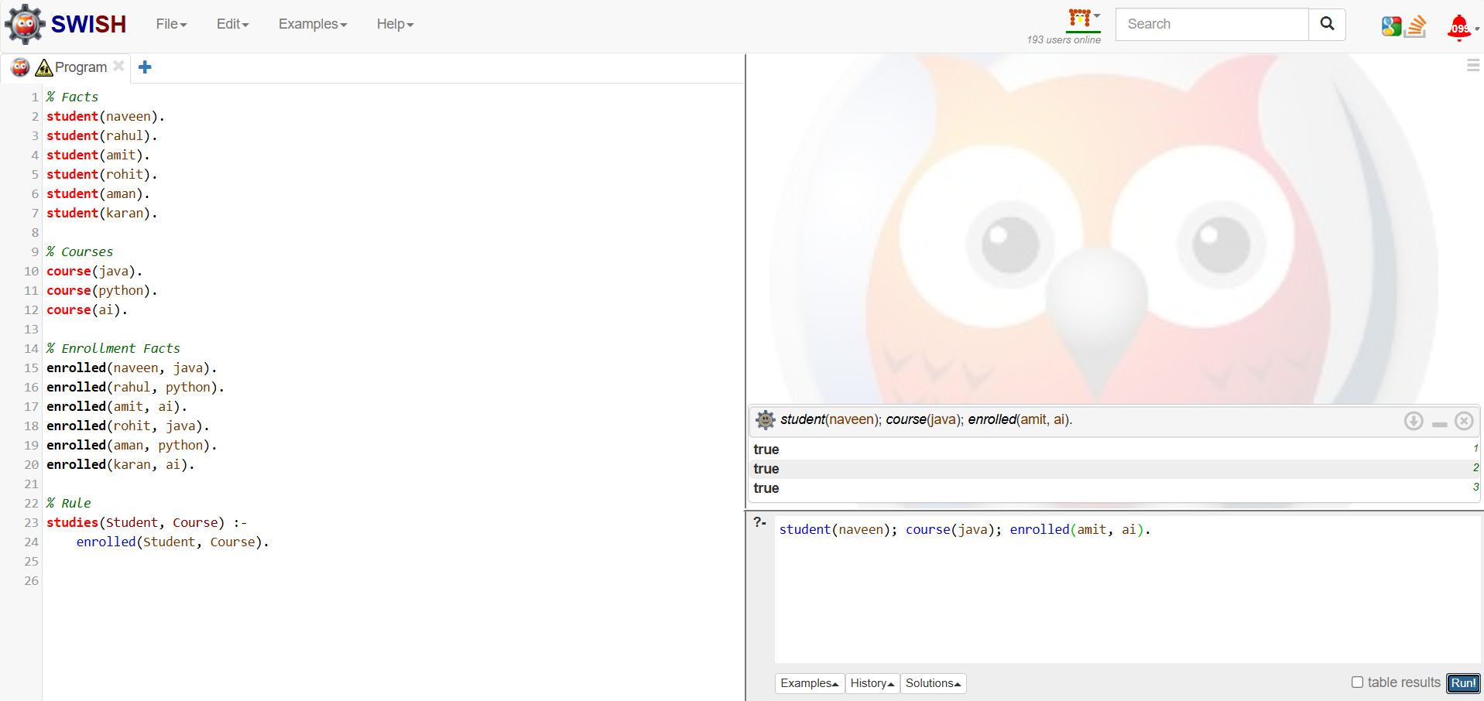

Experiment – 02

Implement arithmetic operations, Factorial, and Fibonacci Series using recursion.

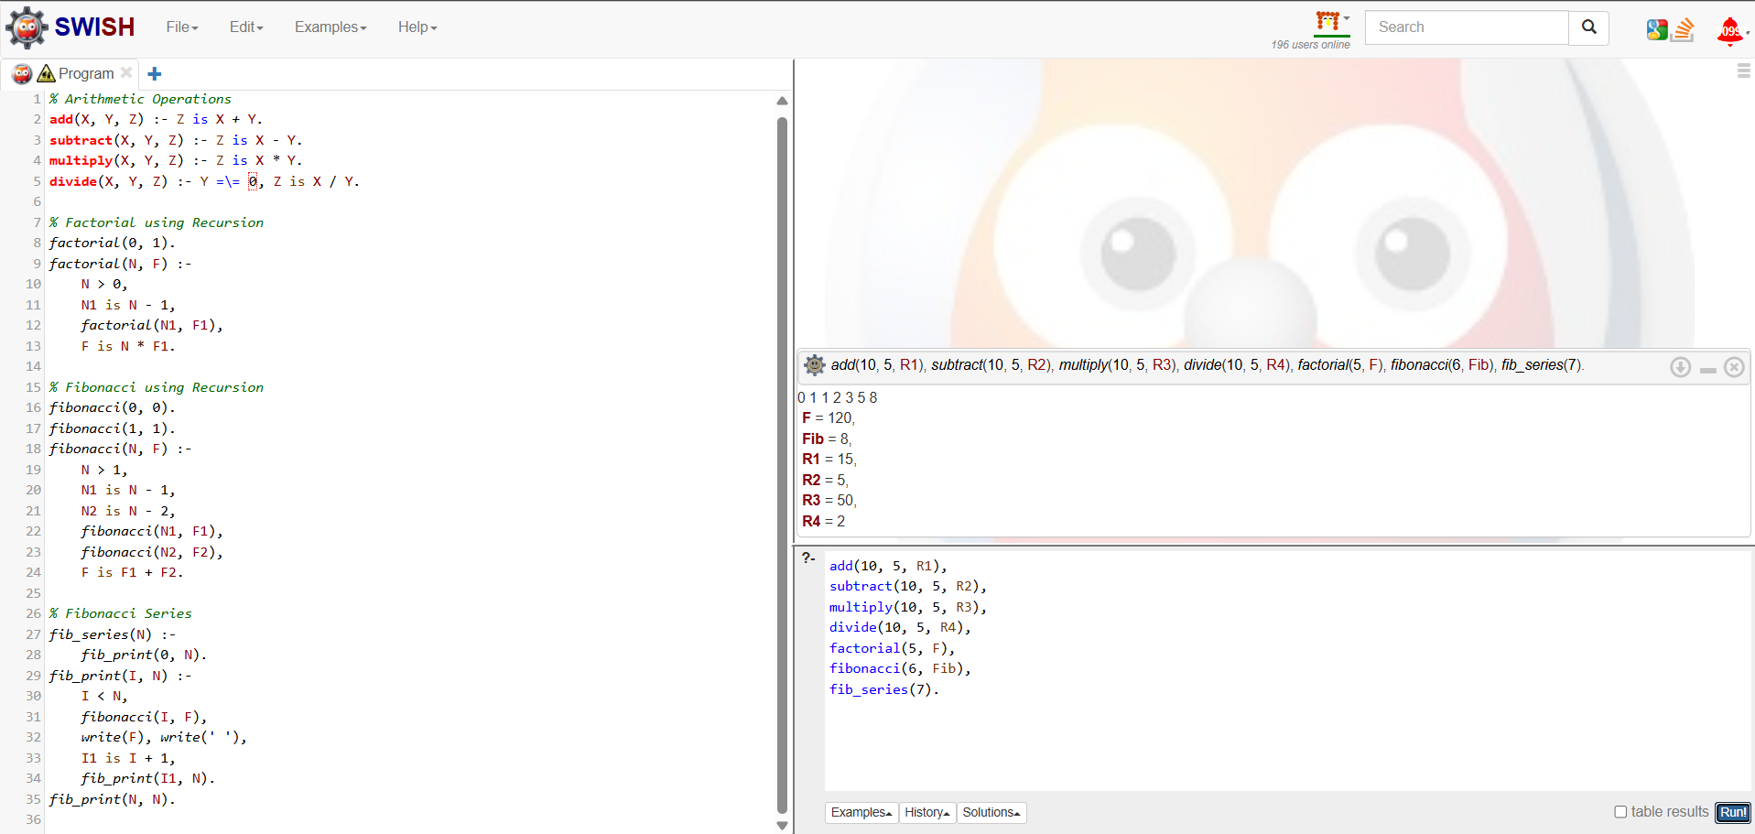

Experiment – 03

Perform append, reverse, member search, and list length operations.

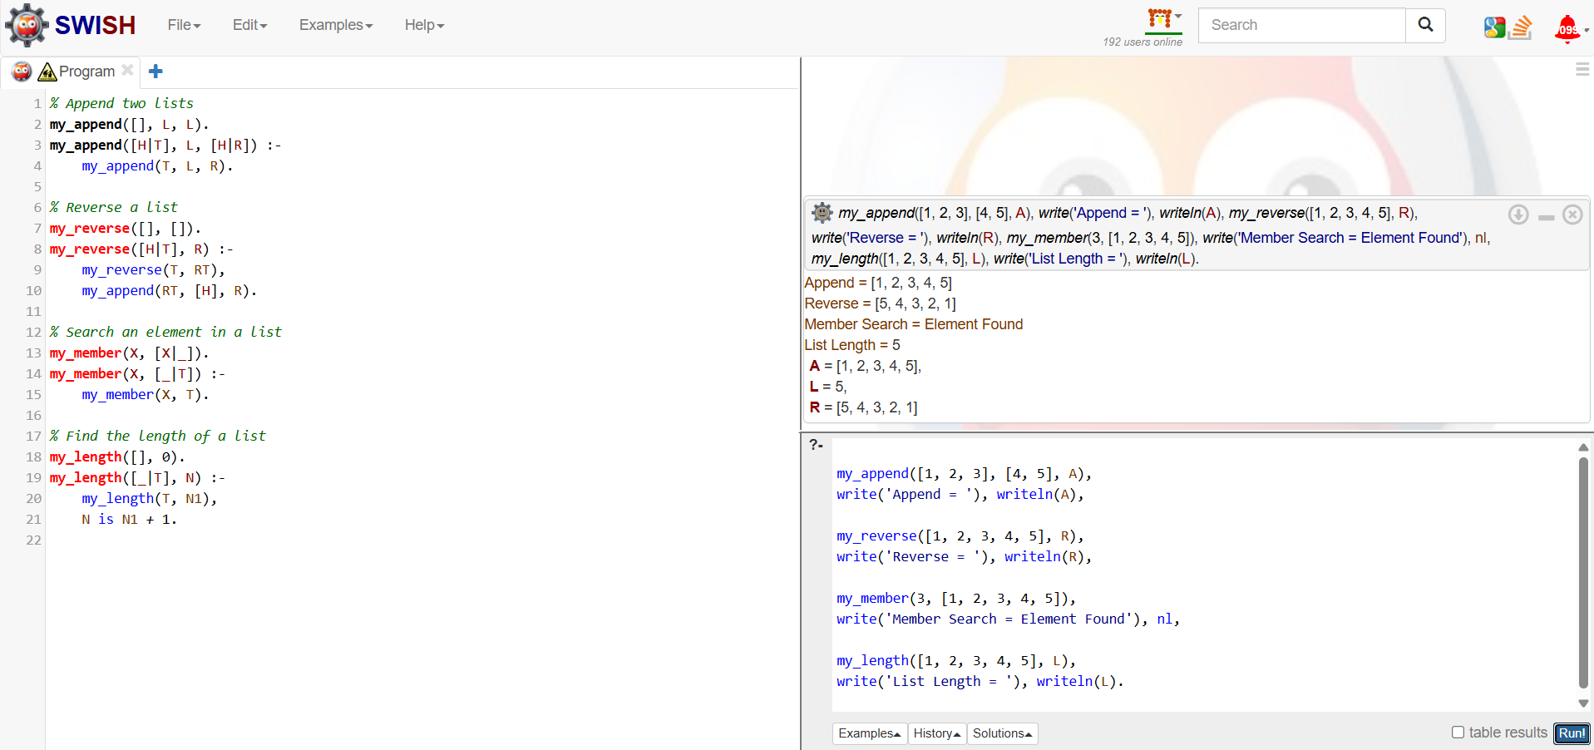

Experiment – 04

Develop a timetable database and answer queries regarding faculty, subjects, and classrooms.

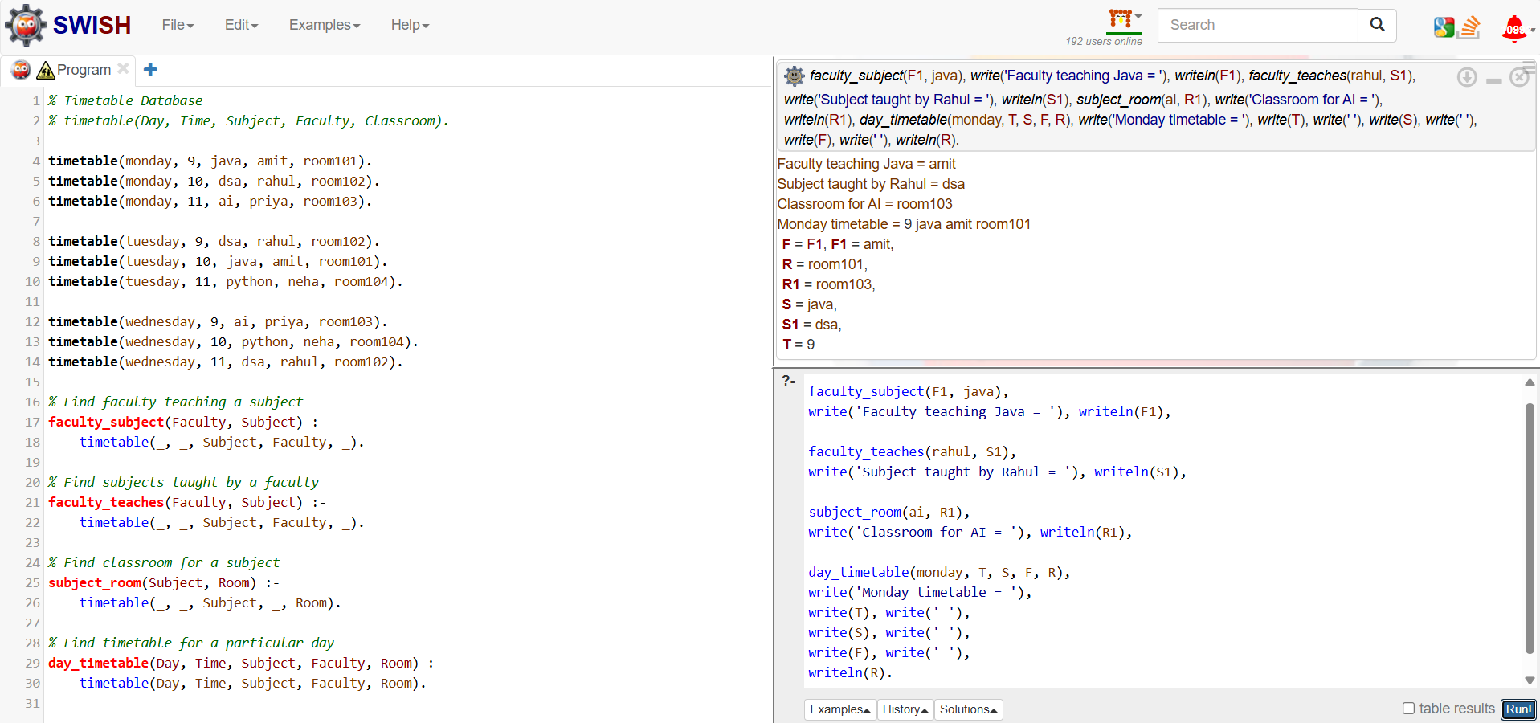

Experiment – 05
Classify students as topper, average, and fail using rule-based reasoning.

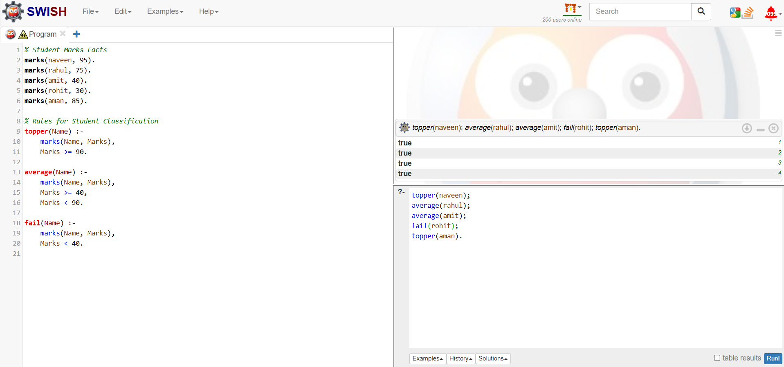

Experiment – 06
Design a route recommendation system using city connections and inference rules.

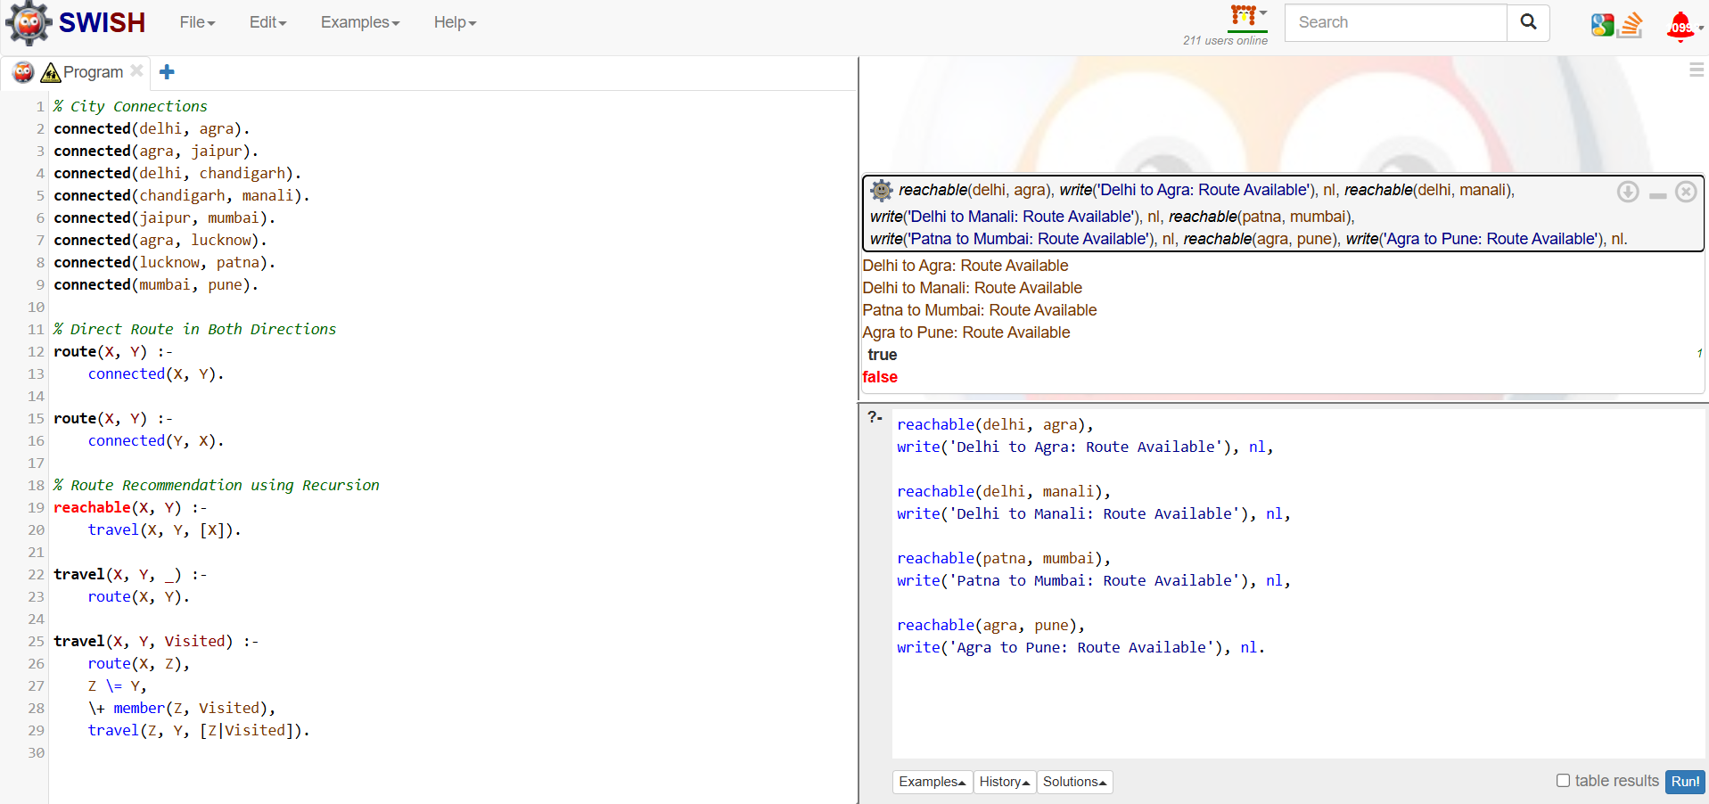

Experiment – 07
Implement BFS to find shortest paths in a graph.

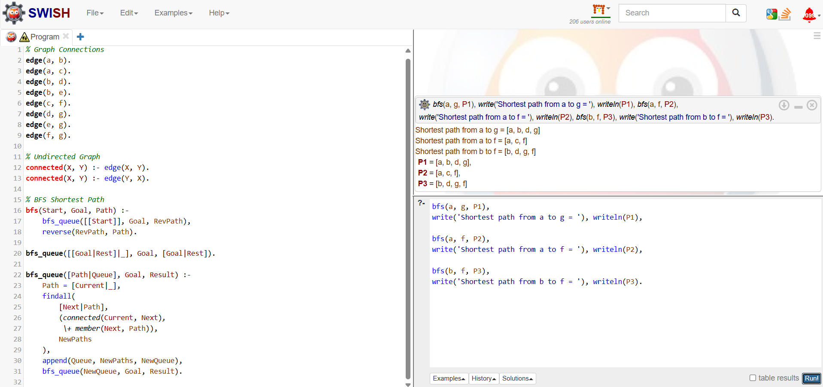

Experiment – 08
Implement DFS to explore state-space trees and graphs.

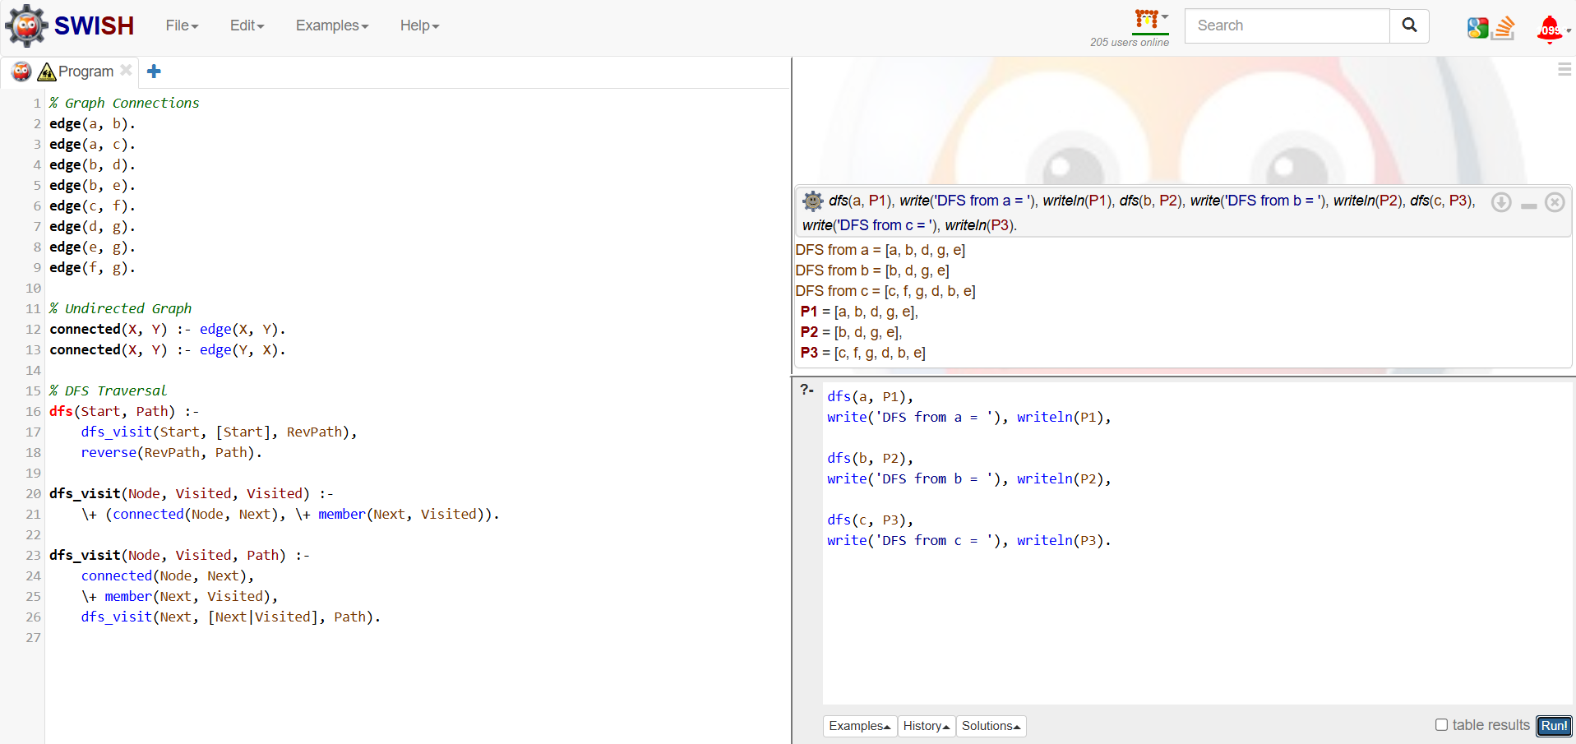

Experiment – 09
Implement Hill Climbing for optimization problems.

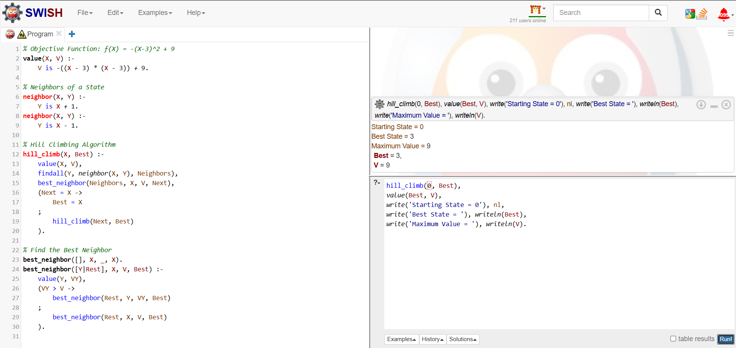

Experiment – 10
Represent Blocks World and validate stacking configurations using predicates.

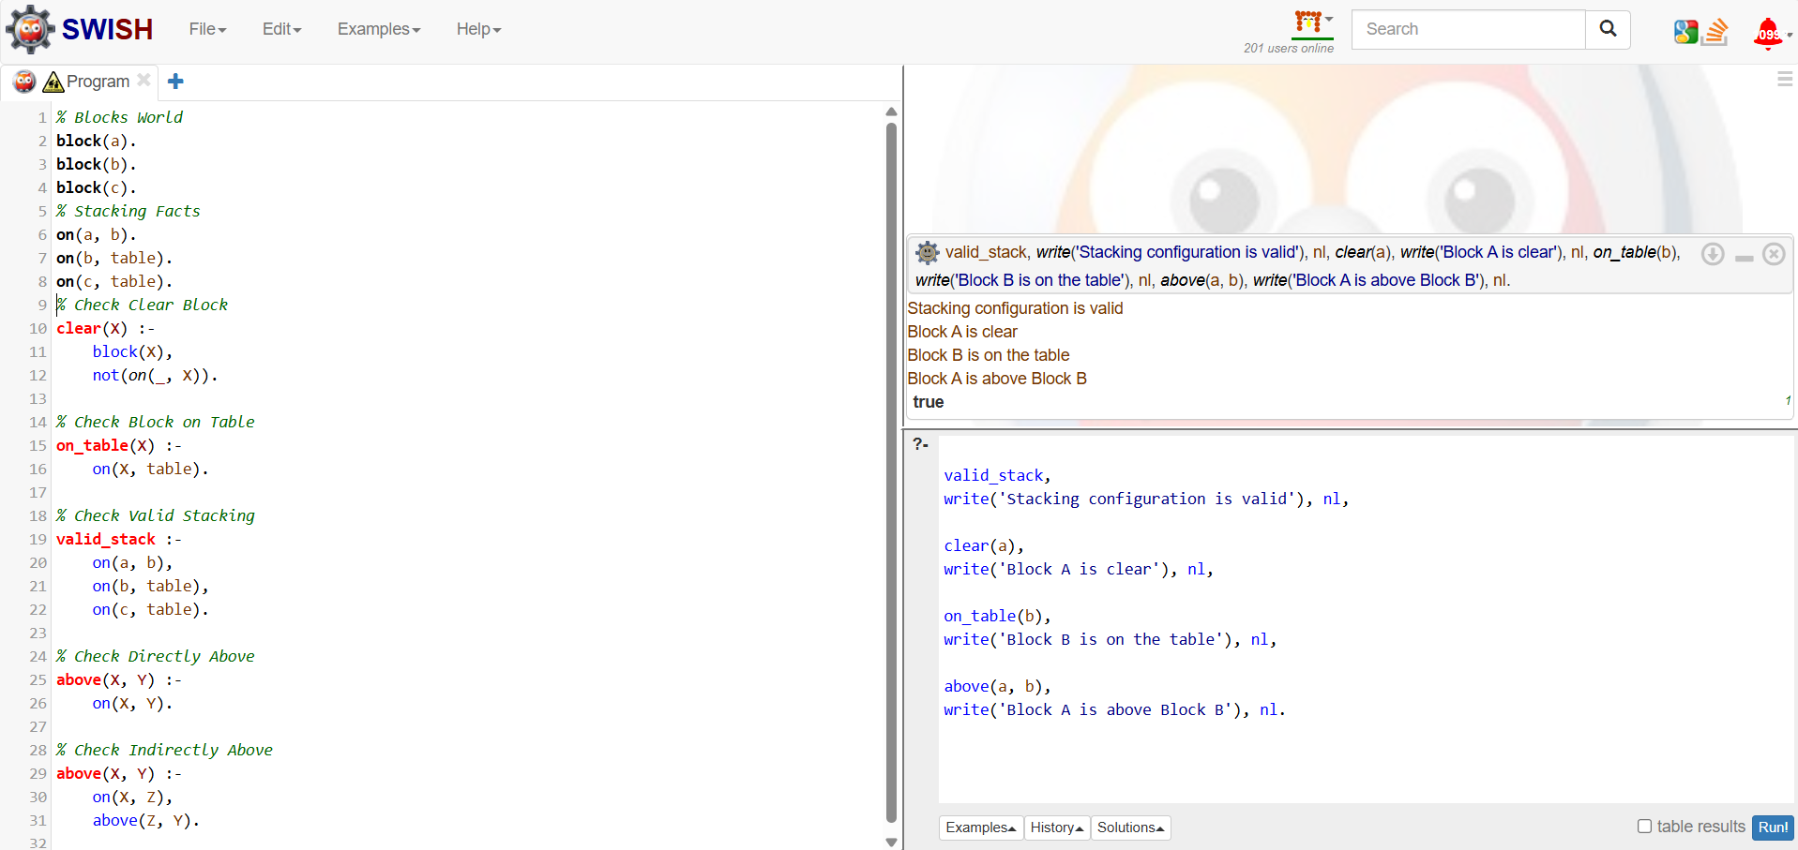

Experiment – 11
Solve the Water Jug Problem using state-space search.

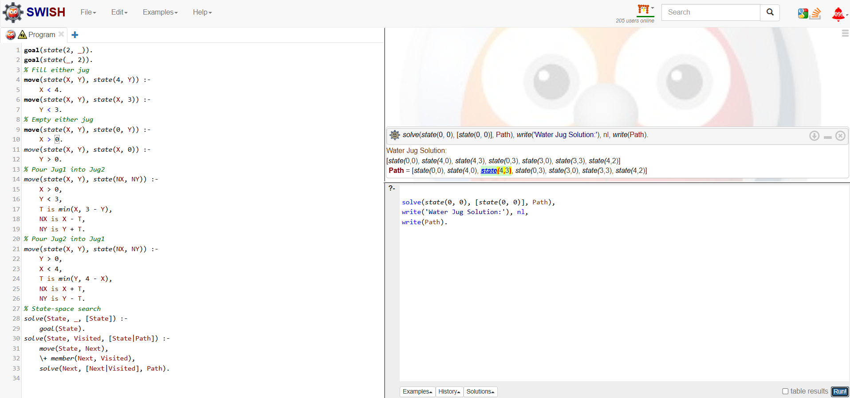

Experiment – 12
Develop a simple game-playing agent using adversarial search concepts.

